Assignment 2

Pwd: Command used for display current directory.

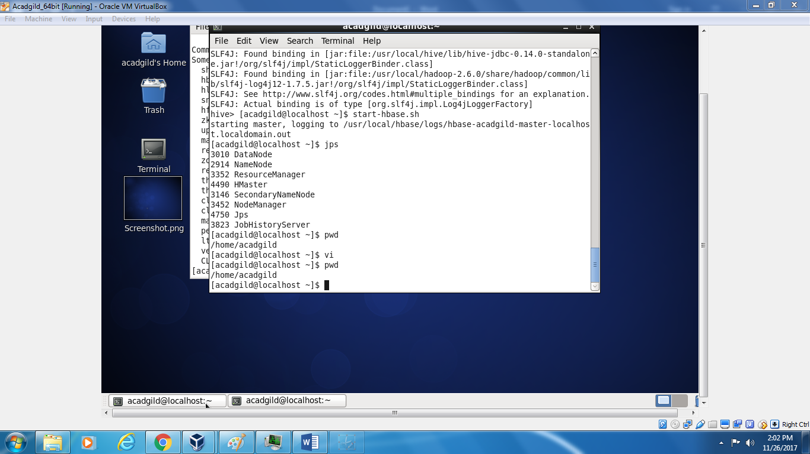

Vi:

It is editor . it is use to edit the file .

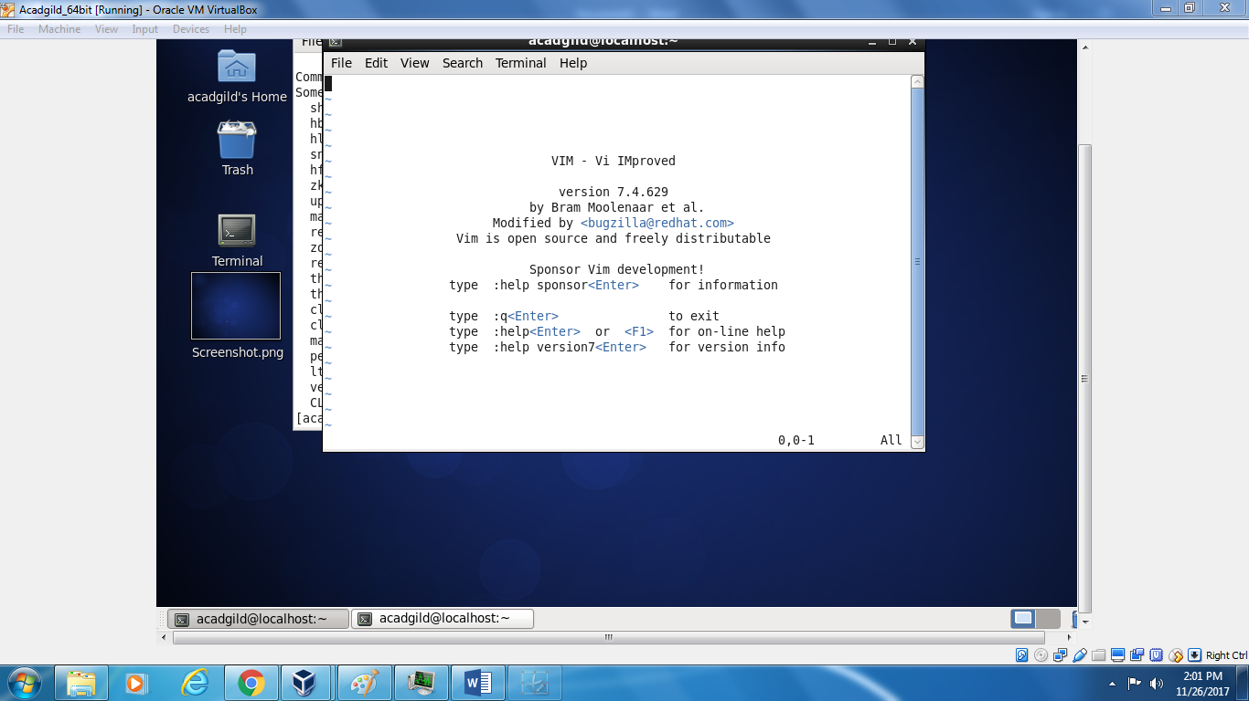

Touch: it is used to create empty file(0 Byte file).

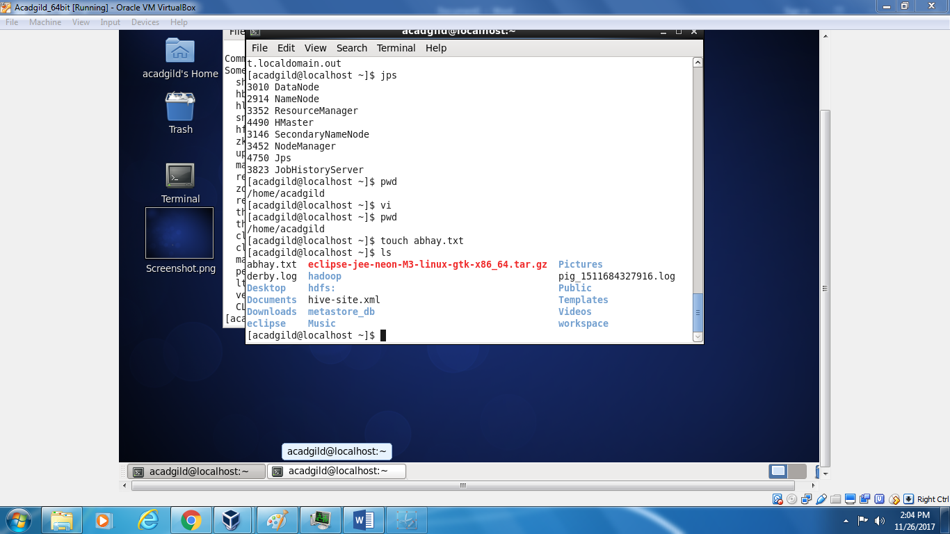

Mkdir:

It is used to create directory

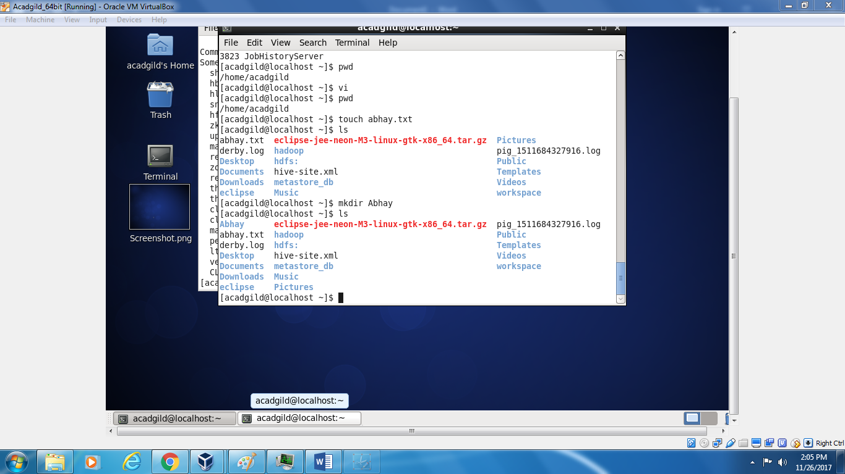

Rm

It is use to remove file

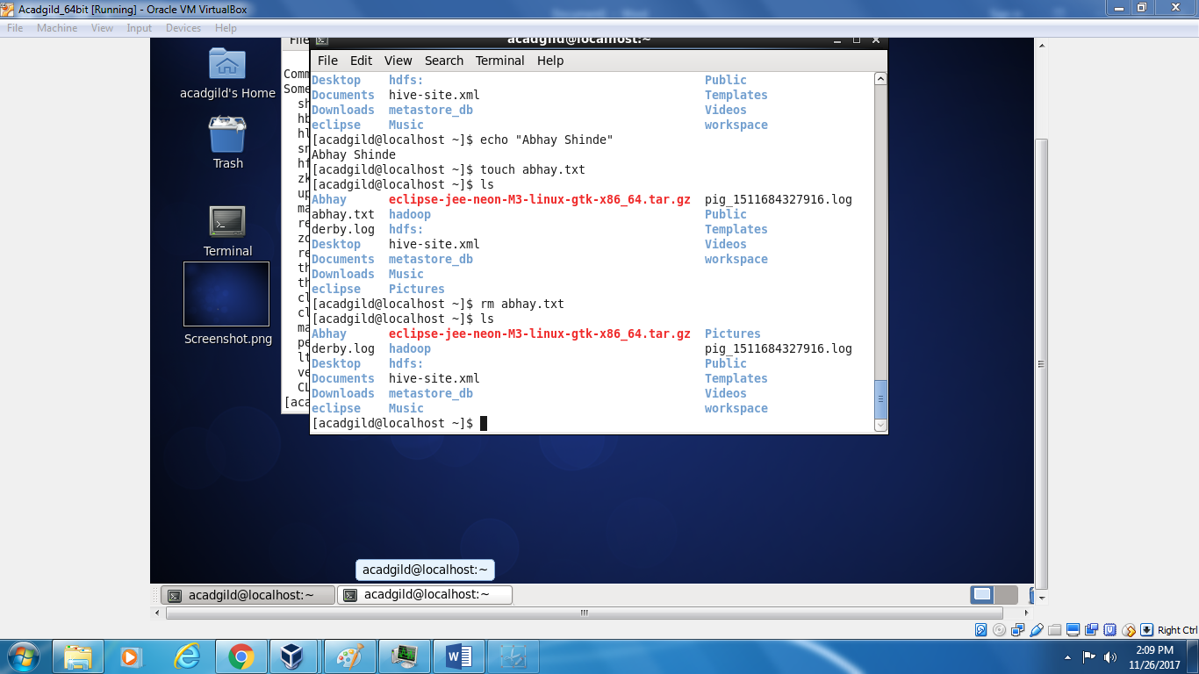

Is : used to list the files and directory .



Echo: is it used to display message, it is used as Print statement similar as in C language.

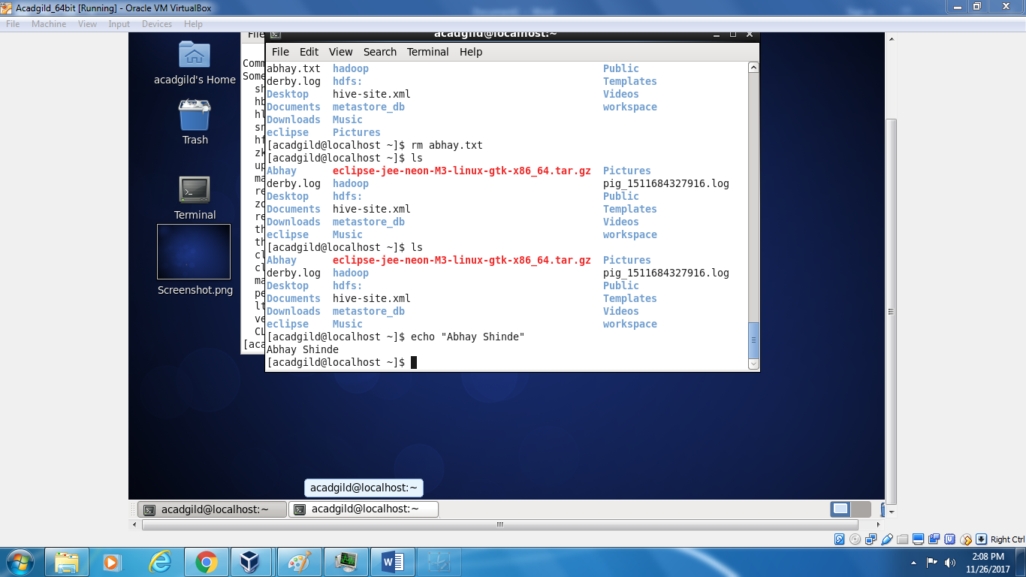

Cat: it is used to display content of file

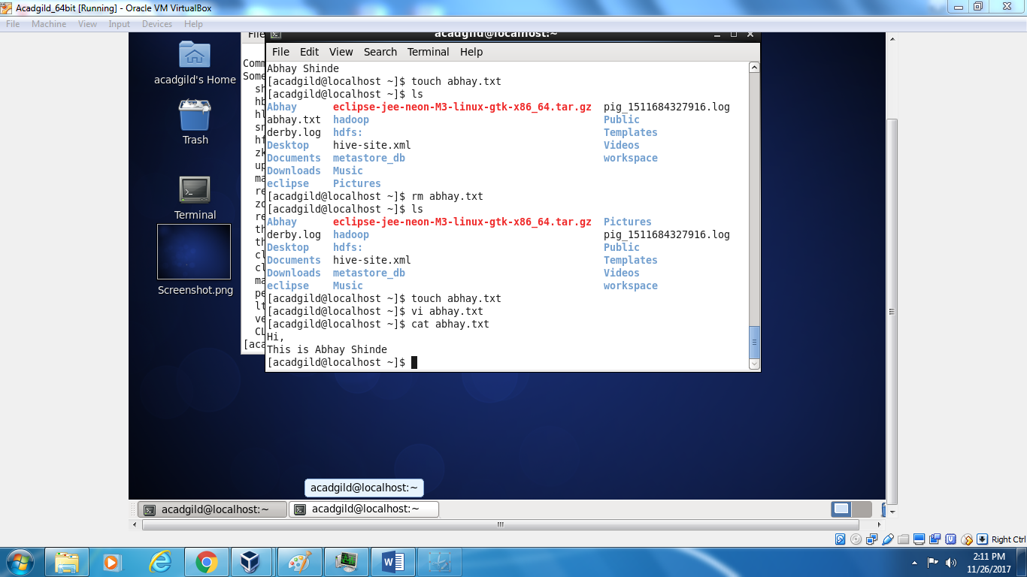

Who: it display the Lists who is logged on your machine

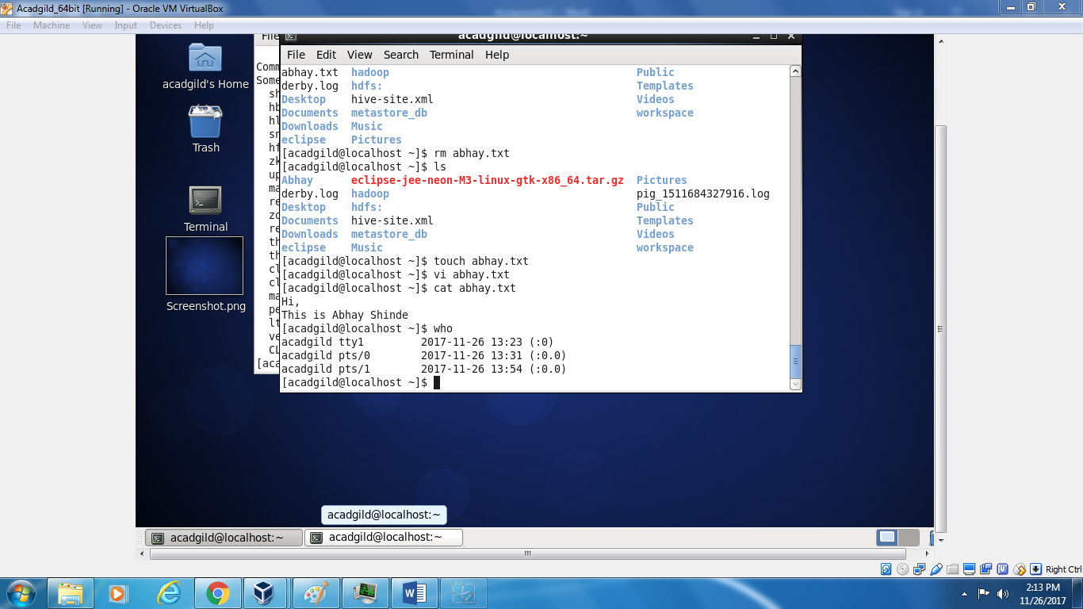

Cd:

Change directory to tempdir   
Move back one directory   
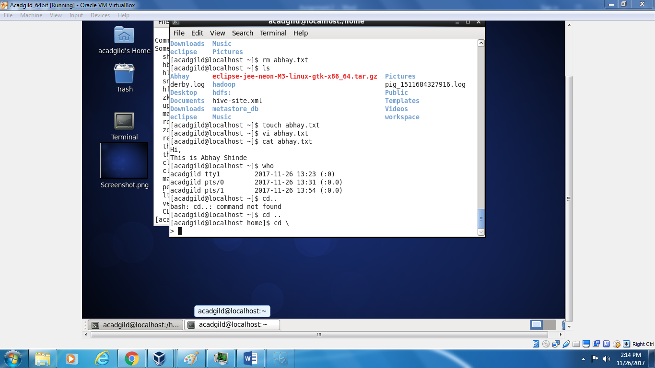

Date : it is used to display date

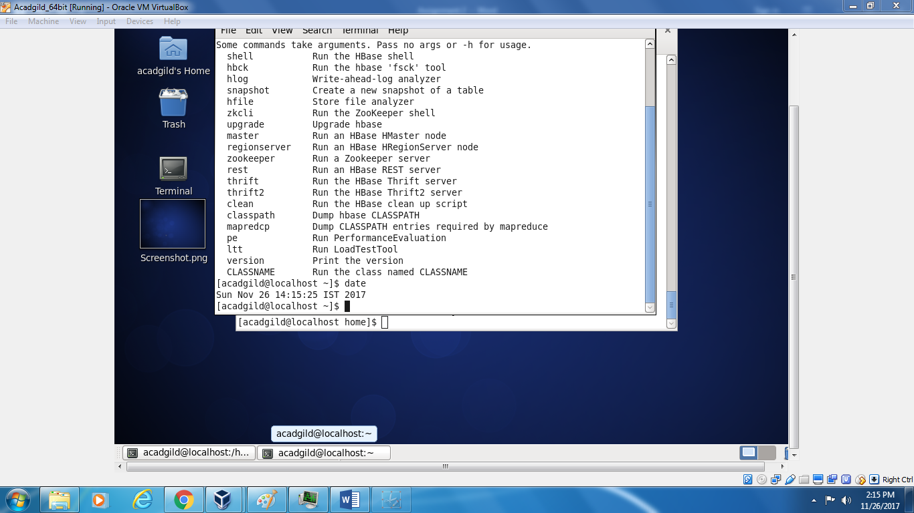

Cal: display calender

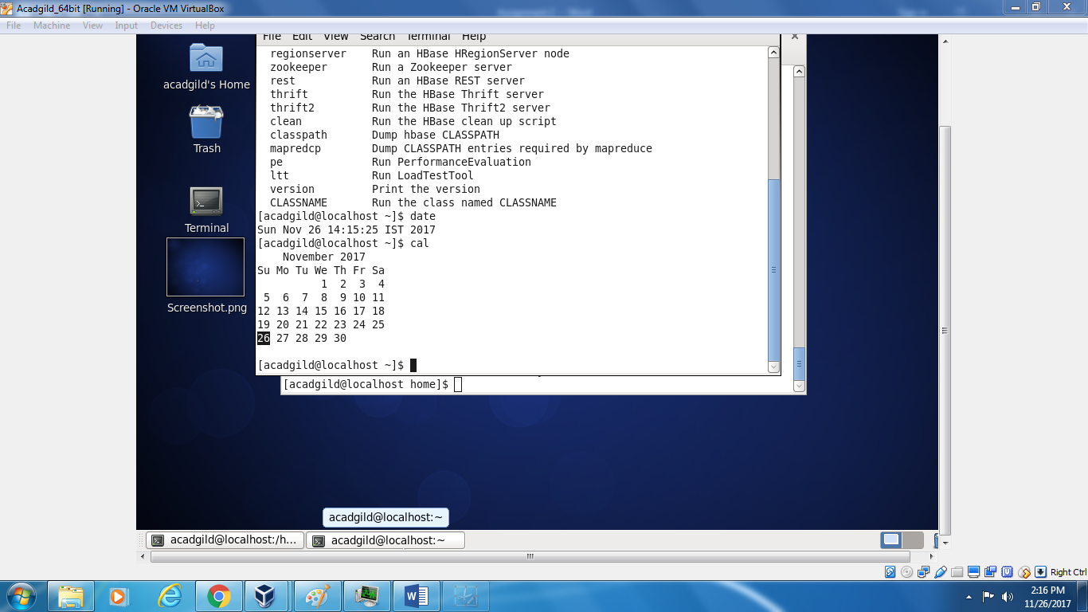

Mv: Move or rename files

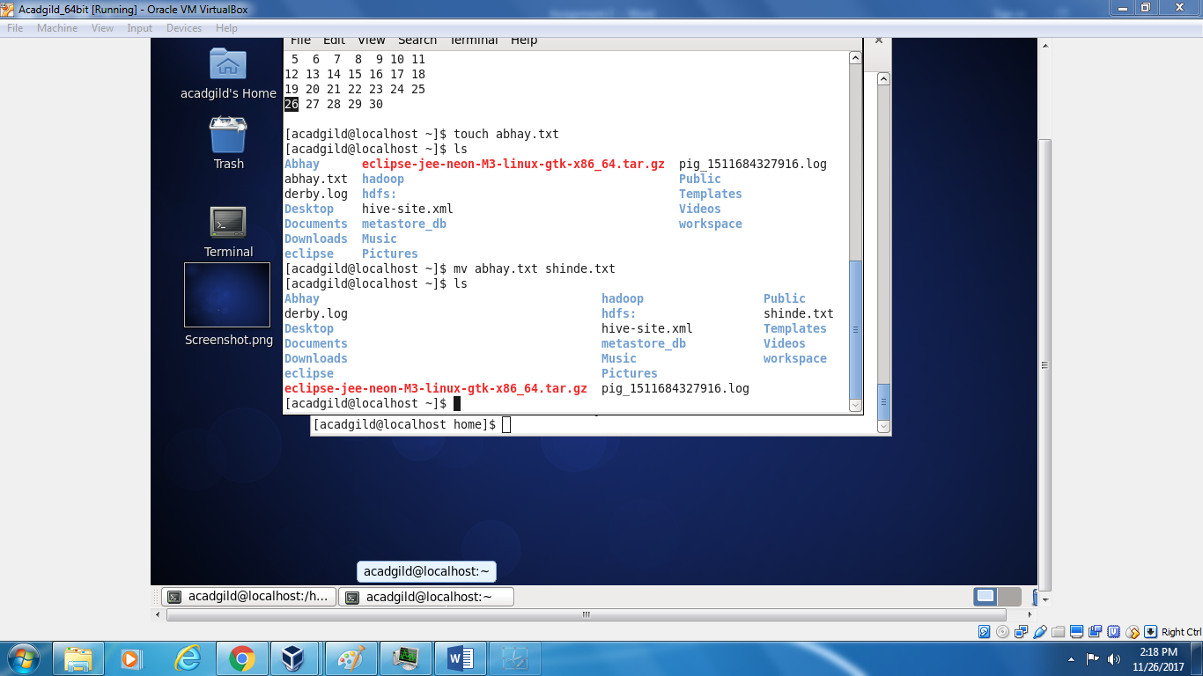

Cp : copy files

Which: display the pathname of files

